Tiết 2:
UNIT 1: A VISIT FROM A PENPAL
GETTING STARTED- LISTEN& READ
1. GETTING STARTED: ( Trang 6)
Work with a partner. A foreign pen pal is coming to stay with you for a week. What activities would you do during the visit?
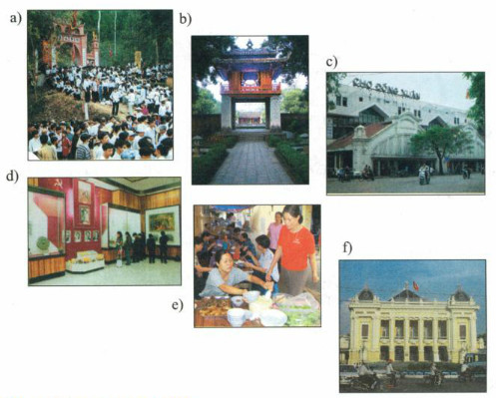
2. LISTEN& READ (Trang 6-7 SGK Tiếng Anh 9)
New words:
1. correspond(v): trao đổi thư từ
2. Mausoleum(n): lăng mộ
3. mosque (n): nhà thờ Hồi giáo
4. depend (v): lệ thuộc
5. keep in touch (v): giữ liên lạc
Lan’s Malaysian pen pal, Razali Maryam, was staying with Lan last week. Maryam is from Kuala Lumpur. Maryam and Lan have been pen pals for over two years and they correspond at least once every two weeks, but this was their first meeting.
On Maryam's first day in Ha Noi, Lan took her to Hoan Kiem Lake. Like Kuala Lumpur, Ha Noi is a busy modern city. Maryam was really impressed by the beauty of the city and by the friendliness of its people.
Over the next few days, the girls visited Ho Chi Minh's Mausoleum, the History Museum and the Temple of Literature, as well as many beautiful parks and lakes in Ha Noi. On Friday, Maryam wanted to visit the mosque on Hang Luoc Street. Lan used to walk past the mosque on her way to primary school. However, this was Lan’s first visit. She enjoyed the peaceful atmosphere while Maryam was praying.
“I wish you had a longer vacation,” Lan said to Maryam at the end of the week.
“Yes, I wish I had more time to get to know your beautiful country better. Lan, would you like to come and visit me next summer?” Maryam asked.
“That would be great! However, it seems very difficult for me to have a trip abroad. It all depends on my parents. Anyway, we’ll keep in touch.”
Choose the correct option to complete the sentences.
1. Lan and Maryam usually write to one another every .
A. two years.
B. month.
C. two weeks.
D. day.
2. Maryam was impressed because .
A. Ha Noi was big and modem.
B. Ha Noi people were friendly.
C. Ha Noi was different from Kuala Lumpur.
D. Ha Noi and Kuala Lumpur were the same.
3. The girls went to see .
A. famous places in Ha Noi.
B. areas for recreation.
C. a place of worship.
D. all the above.
4. Maryam wanted to .
A. visit Ha Noi the next summer.
B. invite Lan to Kuala Lumpur.
C. stay in Ha Noi.
D. visit Ho Chi Minh City.

